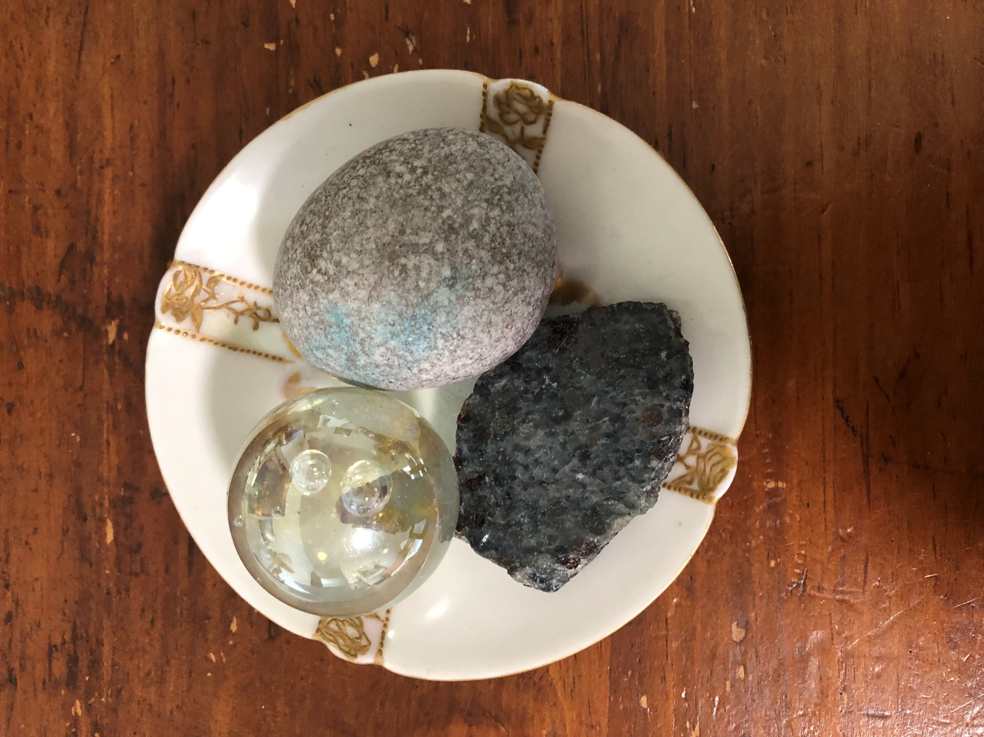
Old things: Granite (I think) rock from Lake Erie when it went insane from abuse by humans, picked up when John and I were there and I was interviewing Canadian naturalists about hormone disrupting synthetic chemicals’ effects on cormorants about 30 years ago; clear glass ball was a gift from my little granddaughter (now 15) about 10 years ago. I often hold these two in my hands because to me they represented insanity vs. sanity. About two years ago, I found and loved the third one, whatever it is. These three are resting comfortably on a four-and-a-half-inch-diameter saucer from one of my grandmother’s tea sets. The photo was taken on a large, old, dining-room table my justice-champion, now-in-eternity husband, John Conner, had when I moved in with him in 1990.
My Archiarchy Diary: Here’s What I Did So Far
Introduction
March 30, 2025: This started about 18 months ago when I took a writing class by Derrick Jensen. When Julia Newmann described the book she was writing with Alice Belz, Her Conscious Anger: Workbook for Women, I knew I needed it. I got on Julia’s email list and in September (seven months ago) when it arrived, I was escaping an unhealthy marriage and spending a week in a local motel. This book helped me start healing.
A couple months ago, Julia and Alice had a series of four workshops; I signed up. I felt a huge sense of joy being with them plus one other woman; we shared deep things with each other as Julia and Alice held space for us. I started watching videos and was drawn to Julia’s interview with Anne-Chloe Destremau. I watched it six times. I already hated patriarchy and was captured by the way Anne-Chloe talked about the Women of Earth gathering in Portugal. I even made a screensaver for my desktop with Anne-Chloe holding a bubble. That helped me imagine my own bubble.
Next, I watched Derrick interview Clinton Callahan. I had ordered Cavitation: The Emergence of Archiarchy by then and was reading it eagerly, underlining like crazy. I’m rereading it more slowly and continuing to underline it. On page 131, Claire said to Edith, “This is why I need you to write!”
All along, I had a plan to write my beginner’s history so I could send it to about 300 people on my newspaper’s email list when I feel ready to start a Study Group on May Day. So, here I am. I’ve already been trying to describe Archiarchy to friends and family with mixed results, including silence, but that’s OK. If I don’t experiment, I won’t learn how to do this better.
I had started a Beep! Book March 16th and abandoned it, but I dedicated today (Sunday) to feeling my feelings and writing them down. It is so helpful!
There are nine more pages of notes and I want to stop here. I’ll keep going when I feel like it.
I’m excited (I just learned this emotion is a combination of fear and joy) because tomorrow morning I will begin Rage & Fear Club with Hannah and Beth.

Chapter One
( ) = aside from actual discussion; [ ] = notes from my personal life
What is Archiarchy? Cavitation, page 636: “Archiarchy is the creative collaboration of the archetypal feminine with the archetypal masculine. The prerequisite for archiarchy is adulthood. Adulthood is nonexistent in patriarchy.
What does Archetype mean? A perfect example, “first form,” pure form embodies the fundamental characteristics of a thing, inherited, unconscious disposition, instincts long before any consciousness develops, original pattern from which copies are made (cobbled from Google search)
March 12, 2025: Elder interview with Julia
March 22, 2025: BED BEAR CAVE = JUST ME, NO DISTRACTIONS!!! (pull sheet, quilt, down comforter over my head, leaving only room to breathe fresh air from open window over my head)
March 23 [2025 to be understood]: HAPPY, CAREFREE, FEARLESS (These are three words that used to describe me, but they were slumbering; I’m trying to awaken them.)
To-Do List:
1. Check Thoughtware Press to see if Handbook has been published. (no)
2. Rage Club, what is that? Rageclub.mystrikingly.com (got it, started Rage and Fear Club March 31)
3. What the B(l)eep Do We Know? Movie, is it the same as a Beep! Book (no)
March 25: Clinton and Joseph Possibility Coaching #35 (February 27, 2021)
Navigate feelings and emotions; swallowing, hunched shoulders = blocked feeling; show up shining; joy, sadness, fear, anger
* * *
March 26: Radiant Joy Brilliant Love Study Group Week 1 (Full title is Radiant Joy Brilliant Love: Secrets for Creating an Extraordinary Life and Profound Intimacy with Your Partner by Clinton Callahan
Wait until the door opens i.e. Don’t go knocking; some secrets remain secrets.
SILENCE – WAIT [no Questions]
ORDER THIS BOOK! [Arrived March 30]
Basic principles apply to all = myself, groups, etc.
“Beginners’ basic handbook”
Study Group = food, I don’t get this anywhere else, food for all 5 bodies → transformation
Choose from 3 types of love:
Ordinary
Extraordinary
Archetypal
Am I/we willing to start over???
Make existing gameworld IRRELEVANT! [my word for government long ago.]
Build a bridge away from obsolete culture to Archiarchy.
This book is a call for men to grow up, women to wake up.
Patriarchy protects men from consequences of their actions.
Patriarchy = short-term indulgence and consumption
Safe space for a woman to unleash her full potential. [Eat, Pray, Love movie – Liz doesn’t need a husband, she needs a champion.]
FOUND AND ORDERED BOOK on Ebay even though it’s out of print = $27.81 including shipping!!!!!!!!
Phyllis was in his 1975 college meeting and she’s here now!
* * *
Create authentic necessity and the universe will work for me.
Document impeccably and share as widely as possible.
Group intelligence
Great labyrinth of spaces – go to center = archetypal
Archetypal maleness = 0 = terrified = EGO, men are busy trying to be something, put a show on, empty, negative unconscious = stupidity, aggressive
Value of nothingness = huge, can create
Archetypal feminine = everything, infinite
Male plus female together = 3 months of paradise, then mechanical reactions to the irritants, we react, no tools, no clarity = NUMB to reactivity, unfulfilled expectations, if we don’t know how to handle, negotiate, re-negotiate ongoingly, you go numb and more and more numb = dead relationship = ongoing action of nonlinear creating so partner cannot predict what you’re going to say next in the moment, what you’re going to have for breakfast, what’s going to unfold today = NO BOX = ALIVENESS
Anne-Chloe: Where is a man who can help me unfold? Why do I need a man or wait for a man to grow up and get his shit together? = PAIN How can we women help a man to grow up in a way they can hold space for us? Without manipulation. We women handle everything and to think we can have a man handle things with us is unbelievable.
Clinton: initiations.mystrikingly.org
Become an initiator – figure out what I need to learn through writing, articles, websites, talks, trainings, workshops, write books, make videos. The best way to learn something is to teach it. DON’T BECOME A TEACHER. I BECOME AN EXPERIMENTOR. Take more responsibility than I could before = initiation. Responsibility = consciousness in action.
Define myself as an initiator = at EDGE of modern culture, as bridge builder to next culture, as a facilitator of shift to next culture, I will start meeting some interesting people.
TIME OUT (video at 1:10:50)
TOILET PAPER AND PERFECTION
[My experiment]
“I will be happy if I am perfect.”
“I will be happy if I weigh 150.”
“I will be happy if I quit smoking.”
“I will be happy if I quit coffee.”
“I will be happy if I quit alcohol.”

BALLED UP AND FLUSHED
PERFECTION AND PEE DOWN THE TOILET
* * *
One tiny resentment will kill intimacy – make a vow to never let myself have a resentment,
“TIME OUT” THIS DOESN’T WORK FOR ME. “I expect you to hold this quiet space for my nervous system” = expectation – in the moment it is not fulfilled, I create a resentment.
(response to question) PROPOSAL
DEDICATE SOME TIME EACH DAY (5 minutes to one hour) TO BEING THE GREAT MOTHER, BEING THE ALL.
Let identity shift from personality construct to being grounded in entirety, the all, and then it will be less interesting to yourself to narrow you down to be something people can comprehend or can name or can own or be modern culture personality “thing.” Get accustomed to being the Great Mother, one with everything for a few months. Move through rooms like that, brush your teeth like that = broader connection with the vast archetypal nature that is MINE! EXPERIMENT.
(Question or answer to a question) Get four bodies aligned before 5th. I AM A HIGH-SENSITIVE PERSON

Chapter Two (no date)
Radiant Joy Brilliant Love Study Group Week 2 (Full title is Radiant Joy Brilliant Love: Secrets for Creating an Extraordinary Life and Profound Intimacy with Your Partner by Clinton Callahan
BUILDING LOVE THAT LASTS (new title)
No video; nextcutlureradio, possibility psychology
Phyllis mailed him a book
5th body = archetypal
Personal Bullshit Detector
MY JOB = Create something new, something different, experiments
Write Your Article, Website – get my stuff to him
Possiblity Management as Source
Tap into my archetypal nature; I’m born to do this
ENERGETIC CONNECTION in the name of love
YELLOW STUFF = inner “tingling/flow” of LOVE
Vibration = authentic, not modern culture; not esoteric or “spiritual”; WHO CARES ABOUT TRIVIALITIES, COMPLAINTS?
Surf on yellow stuff in my daily life; I’m a missionary – open to yellow love and hold; where
the mystery is alive all the time
UNLEASH MYSELF
SURFING – can’t fight the waves, waves are forces of nature and there’s a way to dance
with them. Earth Coincidence Control Office (E.C.C.O.) = manage circumstances;
“good” vs “bad” = religious
What do I have to do to develop surfing skills?
GO WITH THE FLOW
LEARN TO FLY
We are designed to fly.
REFUSE TO GO BACK TO ZOMBIE WORLD
I do not ever have to go back – radical responsibility
We have capacity to be extraordinary
KIDS (young) HAVE FREEDOM
MAKE EXPERIMENTING A WAY OF LIFE = try new behaviors
Changing myself simultaneously changes my culture. The moment I expect anything from my partner, the possibility of relationship is killed. What I then have is my expectation instead of the relationship.
No effort is wasted, my matrix builds.
BEST GUIDANCE FOR USING BOOK = HAVE FUN!
Take on an ID that makes me brave, kind, healthy, and happy.
Become a door-maker.
Matrix = what’s happened in last 10 years that made me today.
Mechanical skills = where people (or I) am stuck → help others shift.
Chapter Three (no date)
Notes from “An Introduction to Liquid State, Possibility Management (PM) Terms Explained” with Marina Mello and Anja Rohlf
I cavitated to a new space for me, to live in today or maybe always? No – I feel that I need to and want to do this every day. It’s a beautiful way to life. Thank you, all. Thank you, gremlin, for helping me survive patriarchy.
All my bodies are soothed. It’s peaceful in here.
Pause….feel….BE!
I’m more still than usual.
Too many hours watching videos yesterday.*
8:30 pm: pages 17-27 Shall I start a study group? I could. I know I could. Zoom = $16 a
month. I would need to learn more about spaceholding. That’s all. A beginning. Like Clinton in college. Create a flyer – InDesign!!! I KNEW I couldn’t drop it. Maybe I’ll be back. SCRATCH “maybe”???? Clinton says “GO!”
MAY DAY

*All day = Archiarchy. All night = Erin Brockovich!!!
March 28: Cavitated new space

Studying and printing in color Rage Club and Beep! Book; updating looseleaf
Q: Can I afford good journals for BB?
A: Not now! Taking financial responsibility.
Signed up for Rage & Fear Club – Leave the 8 Prisons with Hannah Hirsh and Beth McNamara. Paid $160 after realizing I had forgotten to write down Marita’s $100 check so I used that.
Cavitation page 52: Remington’s Beep! Book
“…a small notepad you carry around for instantly documenting new distinctions, new ideas, or feedback and coaching from others before your Box and gremlin cause you to forget….
“Your ‘Box’ is…your psychological defense strategy, your memetic construct, your comfort zone…the worldview you live inside of that gives your life its look and feel. Your ‘gremlin’ is the active part of your Box that does whatever it takes to keep things the same in your life, because if anything changes or evolves in your survival strategy, it might no longer work to assure survival.”
Hannah showed me how to get on Telegram.
March 29: Put my introduction on Telegram and got a wonderful message from Anne-Chloe!
Read Edith’s chapter (Pages 59-65) STARTING OVER: Start by writing an article and making a website.
Note to Self:
PAUSE NOW
REVIEW
And
KEEP READING CAVITATION
* * *
Looks like I didn’t pause.
Watching Helena Norberg-Hodge: Reflections on the Big Picture (9 minutes, 14 seconds) Psychological pollution, going slower, going local.
Gameworlds by Katharina Kaifler at possibilitymanagement.org
April 1: Women of Earth Movement with Anne-Chloe and Vera Franco (1 hour, 31 minutes, 30 seconds with Spanish translations)
We fiercely love each other
We need each other to be the most radiant, powerful women we can be.
How much fun can we have with each other? (Not the kind of fun that was authorized) FUN = Who can I be around these women that they will celebrate me? How big can I be: feedback culture
Tendency among women to receive the Beep! as punishment or I did something wrong = go back in shell or pressure to be perfect so I belong
We create a meshwork, a field around the world –

WHAT’S YOUR JOB?
WHO ARE YOU?
WHAT DO YOU WANT FOR YOURSELF?
WHAT DO YOU WANT FOR HUMANITY?
Then they paused for five minutes while everyone was writing their answers to these questions:
- What do you want for yourself – future?
- What do you want for the future of humanity?
- In what way to I want to be met with dignity?
- What part of me do I want to be seen and called forth?
When the 5 minutes was up, Anne-Chloe asked:
HOW’S IT GOING? IS THERE ANYTHING WE CAN DO FOR YOU?
[Iona: I did not do this exercise, I’m hiding, waiting for a phone call from Maryann and will do this later – maybe when I’m typing up to here.]
OK, I’ll do this when I finish this page.
April 2: I’m finished now. No more excuses. Here goes:
- I want to be seen and recognized as someone with vast environmental experience gained through 79 years of life on this planet, gradually abandoning patriarchy but not totally. I have a lot to share and will create a website soon so that people who want to learn some of what I have to teach, will be able to reach me.
- I want the future of humanity to grow up and start living with the deepest love and respect for themselves, other people, and all life. I want global peace. I want equality for everyone. I want my friends in Africa to have everything they need to thrive in Archiarchy. Actually, I want that for all of us.
- I want to be met with dignity as an elder, like Julia Newmann did. She videod me and will post it one of these days. I hope people see it.
- I want my vulnerable, don’t-know-everything, don’t-know-much-at-all person to be called forth. TIMES UP!
chuckle
All this is happening, and I’m going to have fun? (Anne-Chloe in a later video re: how can we dawdle and waste our time with distractions like entertainment, sports, etc. when our home is on fire? = my words; hers are in red)
Also, Anne-Chloe answers a question about how to talk with people who are still in patriarchy:
I’m a human from the future. You can become that, too. It’s fun here.
March 31: Started Rage & Fear Club; learned via a video that there is NO FEE TO BECOME A RAGE CLUB SPACEHOLDER (training needed)
April 1: Started reading Conscious Feelings: Living Life Closer to Your Own Truth (revised edition 2022) by Clinton Callahan
April 2: Called LL Bean told them I’m saving trees and want to get off their paper catalogue mailing list. I did not say that now I see it as a materialistic vehicle for wealthy people (even though I really like my LL Bean bathing suit which my son and his wife mostly paid for as my Christmas present and the Nordic sweater I bought for myself). I HAVE A DISTINCTION NOW: I AM NO LONGER AN LL BEAN SHOPPER!

Conclusion
Do you feel like you might be drowning? I do sometimes but I just keep swimming and loving it. All this “work” doesn’t feel like work at all. Now I prefer Clinton’s books to romance novels, Possibility Management videos to Sandra Bullock’s movies. My life is really changing.
I will be starting an Archiarchy Study Group May Day. Whoever joins me will be co-facilitating and we will learn how to hold space for each other. There are no leaders. There is no hierarchy. We are leaving patriarchy behind. We will figure out collectively what to do and how to do it.
If you want to talk more and/or have questions, please email me at ionaconner@pa.net.
Thank you from my heart for reading this.
Adios, patriarchy.
Hello, Archiarchy!

